idf europe

Diabetes Advocate Award 2024

Rewarding advocacy for the benefit of the diabetes community!
 | CANDIDATE/APPLICANT
 | Name & Surname
 | Institution/Organisation/Company
 | Position within
 | Address
 | City, Postal Code
 | Country
 | E-mail
 | Website/Social Media
 | Tel/Mobile
 | LIST OF RELEVANT DOCUMENTS
 | ☐ Description of the advocacy activity and efforts, their scope, relevance and impact on people living with diabetes (in appendix, mandatory)
☐ Peer reviewed articles, media publications, letters of support /or any other information that would support your application (max. 5, optional)
☐_____________________________________________
☐_____________________________________________
☐_____________________________________________
☐_____________________________________________
☐_____________________________________________
Date ____________________ |  |  | Signature
Name ____________________ |  |  | _________________________

Please complete the form and return with supporting documents to IDF Europe by e-mail to

prizes@idf-europe.org by 6 November 2024

Supported by
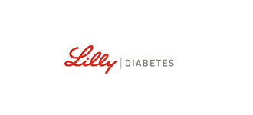

Please describe your advocacy activity and efforts, their scope, relevance and impact on people living with diabetes (3000 words max)

